TransLog Project – Design

Purpose: To make an app that can:
- Record data: In user defined time intervals record shock-data and location-data. (I think that’s all the sensors the Samsung s5 mini is able use)
- Use QR-scanner to scan package-info: Scan a QR-code to obtain the package information. Maybe also consider making a manual data entry feature.
- Display Data: Display the recorded data in graphs and maybe on google map plugin.
- Save data to database: Save data on device and receiving app using SQLLite Room.
- Send Data: Via Bluetooth send data to the receiving app.
Addition features:
- Menu: Navigation menu on top of screen. Menu items: New Package, View Data, Settings
- Settings: A settings activity which gives the user the ability to set: 1) Time for recording intervals, 2) shock sensitivity

Data Model:

The Simple Model:
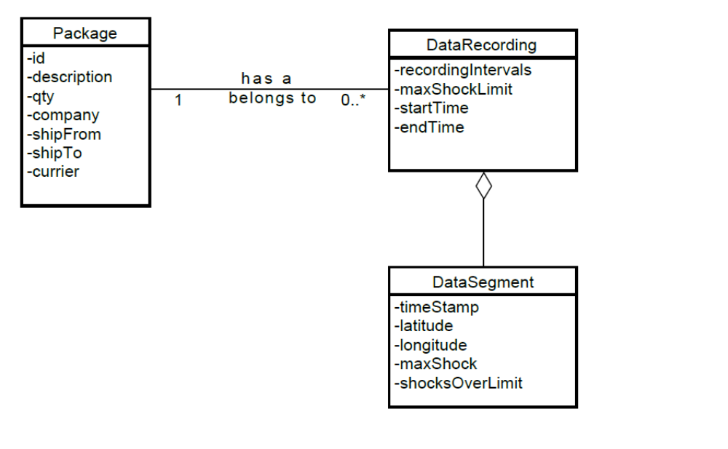

The little more complex (More foreign keys)

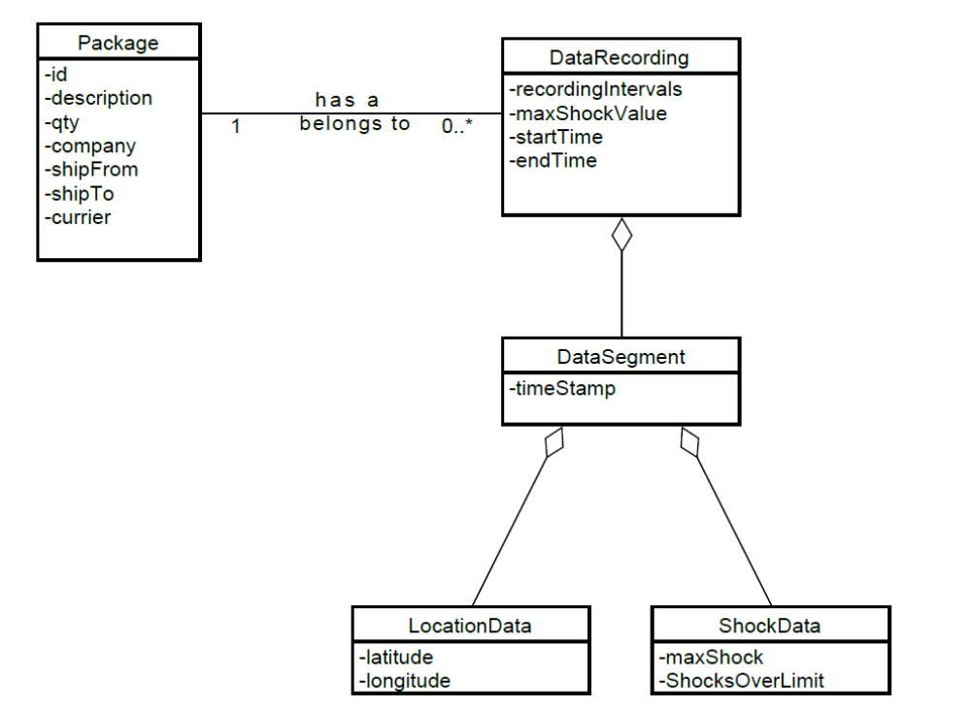

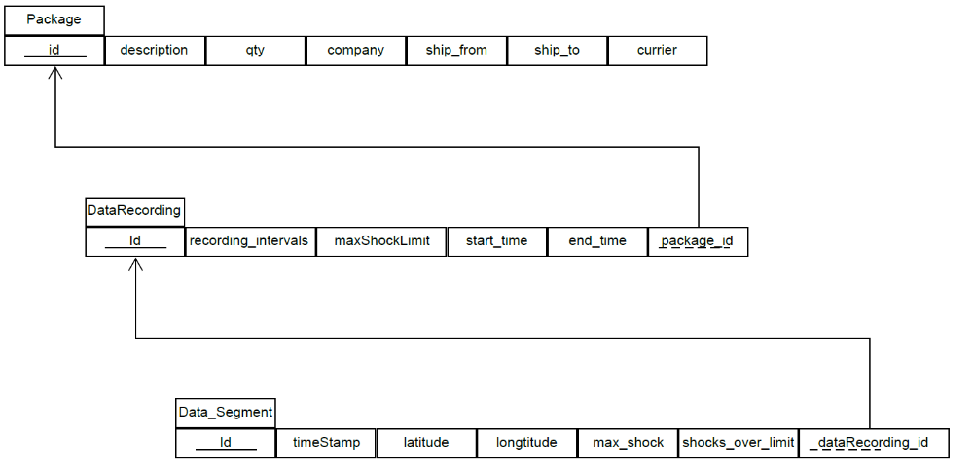
Relational Model: (The simple one)

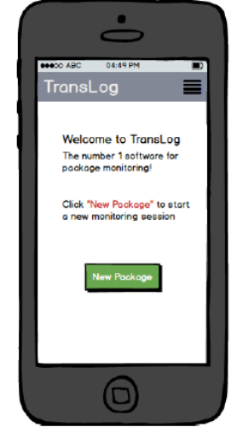
Activities:
1
MainActivity
The first welcome page the user sees.
- Welcome message
- Able the start recording data on new package.
- From menu can access settings and View old data recordings.

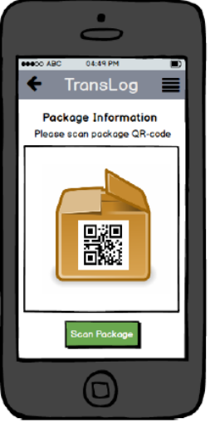
2
ScanPackageActivity
Here the user a QR-code which in parsed into a Package-object.
- Access QR-scanner.
- The scanned data returns a string which is parsed into a Package-object

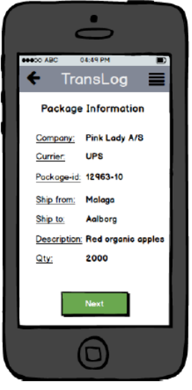
3

DisplayPackageDataActivity
Here the user views the result of the scan
- Note: Maybe implement a feature that allows the user manually to type in data.

4
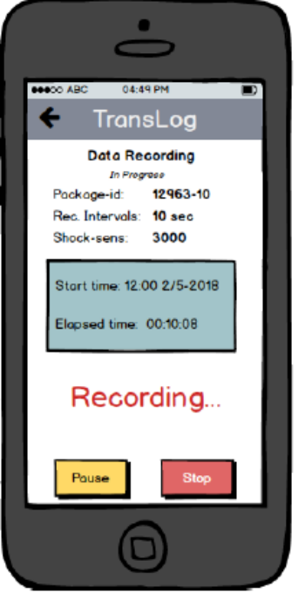
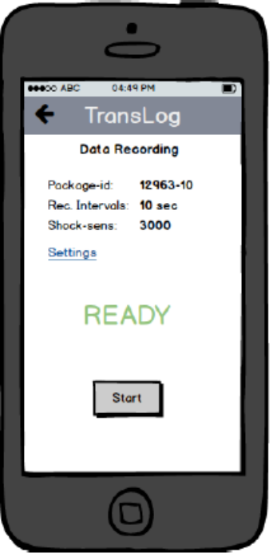
RecordDataActivity
After the package is in the system it’s time to start the data-recording activity
- Display package id
- Display selected settings
- Shortcut to settings in case user wants to change.
- Big button that starts recording data.
- Once recording the screen displays start time and elapsed time and shows a “recording” message and a stop button.
- When recording starts a DataRecording-object is instantiated and DataSegment-objects are made from each recording-interval and associated to Datarecording-object and saved to database

5
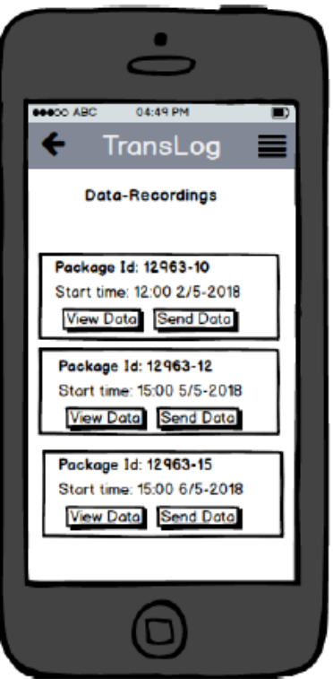

DisplayRecodingsActivity
When the data-recording is stopped the user views the data recording-object on a list along with old recordings. Here the user can choose to either view the data or send the data.
- A list view with a custom list adapter.

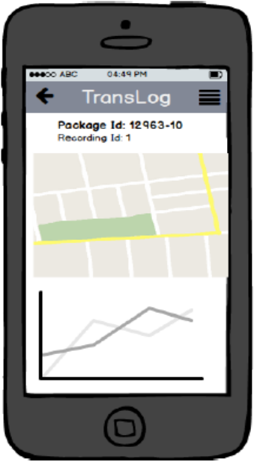
6. (View Data is pressed)
DisplayRecodingDataActivity
The user vies the data.
- A graph that displays the max-shock value for each data-point.
- A graph that displays the number of shocks for each data-point(recording interval) that exceeds the chosen shock-sensitivity-limit.
- A google map plug-in that can render the route from the location data

7. (Send Data is pressed)

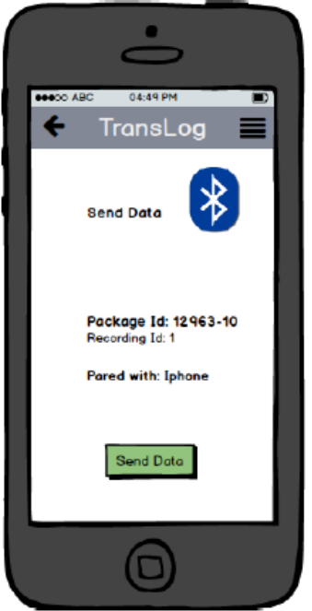
SendRecodingDataActivity
The user sends the data to a receiving app.
- Blue Tooth connectivity
- Par with the desired phone.
- Send data
- Display success-message

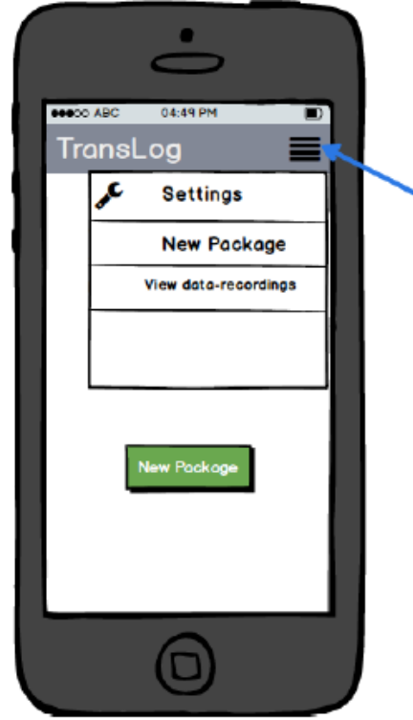
Menu- and SettingActivity

MenuWidget
From selected pages in the app the user can access the menu
- New Data recording
- View Recordings
- Settings
- NOT visible while recording data
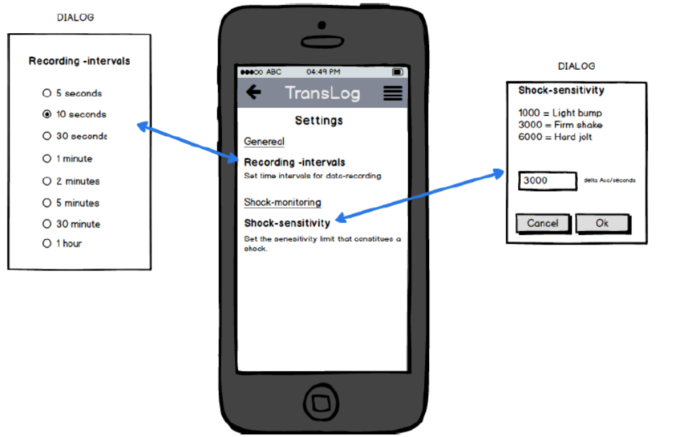
SettingsActivity
Here the user edits the settings. Use the built-in preferences class in android studio

